# Trello

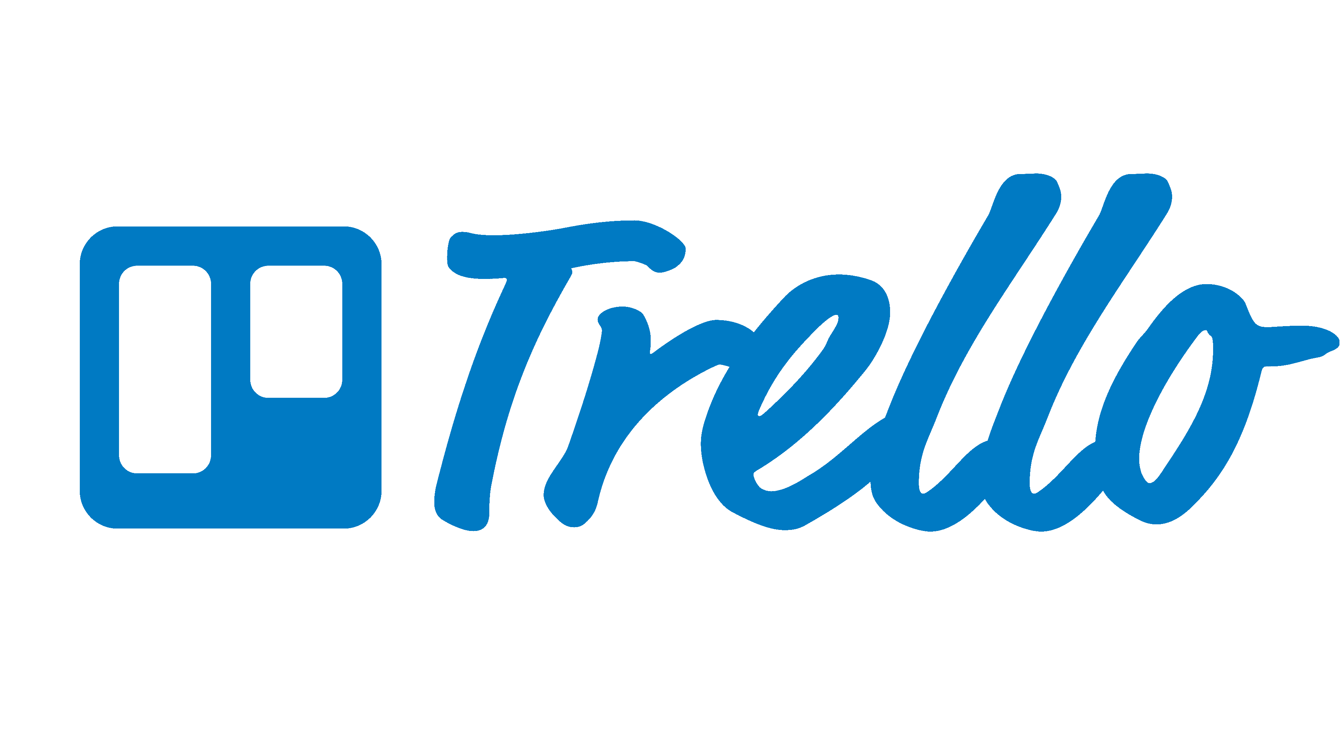

## Overview

Trello is one of the most popular lightweight project management tools out there. It’s favoured by start-ups, small teams, temporary projects and in various other scenarios where a project manager needs a minimal structure to keep things organized.

It is also a good tool to use when introducing a team to an Agile Kanban workflow. The basic interface has boards, columns, and cards as the main units of operation. However, you will quickly run into Trello’s limitations if you want to have a more elaborate team process or if you want the whole organization to work with the same tool. Trello offers paid premium plans, which extend the functionality, but at $10/user/month it struggles to compete with the other tools in this list.

## Pros

* **Very lightweight:** It can be set up in just a few minutes and the structure is easy to maintain.
* **Intuitive interface:** Team members can be on-boarded quickly.
* **Price:** Free version is good enough for most simple projects and lightweight processes.

## Cons

* **Very lightweight:** The flip side of being lightweight is that it is hard to provide a lot of options for customization for companies with more elaborate workflows.
* **Information expires quickly:** Limited activity log and search capabilities coupled with minimal labeling options make it hard to track information over a longer period of time.

# [Basecamp](https://basecamp.com/)



## Overview

The wildly popular web application framework [Ruby on Rails](https://www.toptal.com/ruby-on-rails/after-two-decades-of-programming-i-use-rails) was created to build Basecamp. The project management tool itself has seen some steady growth over the last 15 years and seems to have gained the most traction with digital and web design agencies. It achieved this due to its combination of a lightweight interface with powerful collaboration tools like a built-in chat, file-sharing, and an ability to collaborate with clients within the Basecamp. Another great concept is that this tool is [“adoptional”](https://medium.com/@jasonfried/basecamp-3-adoptional-555e26a4b8b2). Team members don’t have to create accounts to use it and can easily collaborate only occasionally.

However, Basecamp lacks boards, estimations, and other attributes necessary for agile development. While there are third-party applications, that can help you achieve an agile setup, other tools in this list have these features out of the box.

## Pros

* **Pricing**: A fixed price per month means that costs don’t grow with the addition of new employees.
* **Lightweight:** Basecamp is easy to start using but also has powerful features.

## Cons

* **Scrum/kanban boards:** Boards are only available through third-party tools, which makes Basecamp less competitive with other midweight tools.
* **Sprints:** Sprint tracking is supported only via third-party tools.
* **Chat:** Although it touts itself as a replacement for Slack, communication UX is not on par with dedicated real-time chat tools.

# [Asana](https://asana.com/)

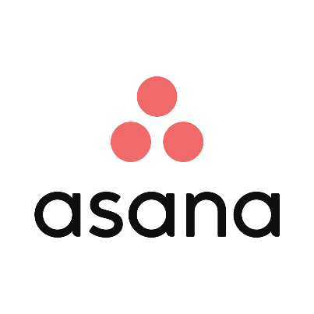

## Overview

Initially developed as an internal tool at Facebook it quickly took off and became a separate tool in its own right. In its early stages, Asana focused on smaller teams and has only recently started to incorporate features like “Portfolio” and “Workloads” aimed at bigger businesses.

An interesting differentiator is an ability for any task owner to see how their tasks impact overall business goals. Moreover, the co-founder has stated in a recent interview that AI and [machine learning](https://www.toptal.com/machine-learning/machine-learning-theory-an-introductory-primer) will be used in future features for intelligent suggestions on deadlines, workloads, and planning.

## Pros

* **Strong search:** Advanced options make it easy to find tasks and files among multiple projects.
* **Timeline view:** Asana offers a very intuitive Gantt chart type view with easy rescheduling and task dependency management.

## Cons

* **No multi-assign:** Tasks can only be assigned to one person.
* **Scrum and sprints:** [Scrum workflow](https://www.toptal.com/project-managers/scrum-master/common-scrum-master-mistakes) with sprint tracking is supported only via third-party tools.

# [Wrike](https://www.wrike.com/)

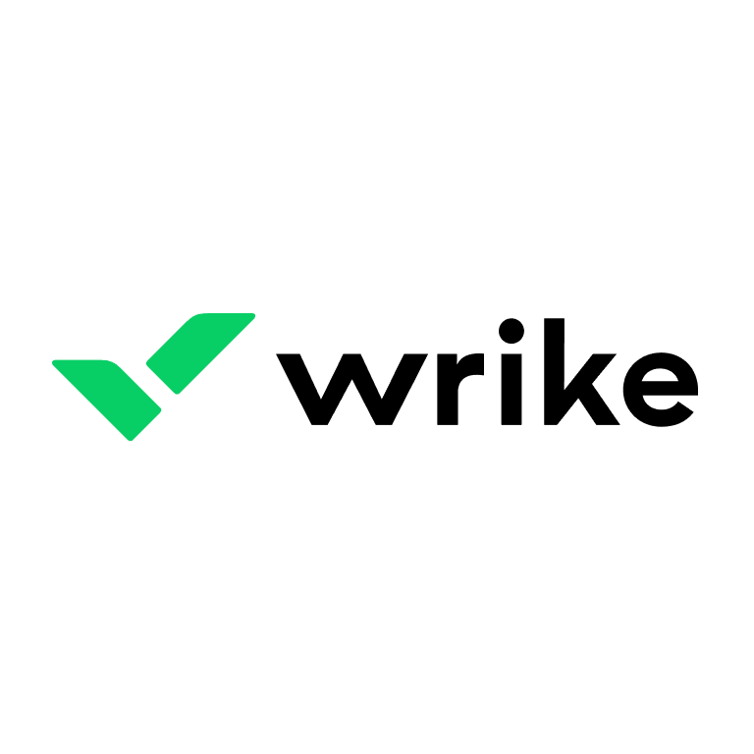

## Overview

Due to its high customizability, Wrike could almost be in the heavyweight category, competing with Jira. It’s not there yet in that respect but does challenge Jira in terms of UI and UX. The rather strange thing about Wrike is its insistence on having price tiers based on user increments of 5. That coupled with the fact, that you can only use the basic plan with up to 15 users, means that if your headcount goes up to 16, your bill goes from $147/month (159.8) to $496/month (2024.8). Smaller companies should be aware of this fact and not get caught in the price hike.

## Pros

* **Multi-project assignment:** Tasks can be assigned to multiple projects.
* **Pinned notifications:** Wrike offers a unique way to surface relevant information with pinned notifications.
* **Time tracking:** Wrike is the only tool in this article which offers a functional built-in time tracking solution.

## Cons

* **Tricky pricing:** The basic plan is priced in increments of 5 users (5, 10, 15 etc.).
* **Extensions:** Selection of third-party integrations is limited compared to the competition.
* **Sprints:** Scrum workflow with sprints is not available within the tool.

# [Jira](https://www.atlassian.com/software/jira)



## Overview

Jira is one of the most popular Project Management tools out there and is a safe choice for organizations. It can be most fully utilized by larger companies, which need to coordinate between multiple complex projects and have a need to customize the task workflow. For company-wide collaboration, Atlassian also offers Confluence, a data management tool, which integrates nicely with Jira. For smaller teams or temporary projects, there are more lightweight and cheaper tools out there.

## Pros

* **Highly customizable:** Workflow tools allow you to tailor Jira to the way your company operates.
* **Multiple integrations:** An open marketplace provides a lot of integrations with other popular tools like Github, Salesforce, Outlook etc.
* **Scrum and sprints:** [Scrum](https://www.toptal.com/project-managers/scrum-master) workflow with sprint tracking is supported out of the box.

## Cons

* **Long setup time:** The large amount of customization available means that it takes longer for the user to set everything up and to train others on how to use the tool.
* **Complex interface:** Managing roles, boards, issues can feel clunky and the tool is not as intuitive as it could be.

# [MS Project](https://products.office.com/en/project/project-and-portfolio-management-software)

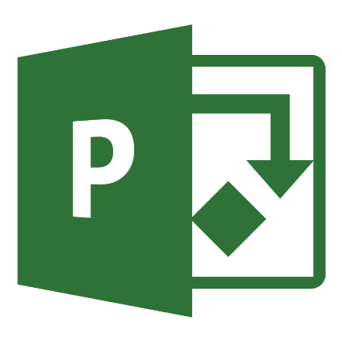

## Overview

MS Project has been around for 30 years and it is still a major player in the market. According to surveys by [Capterra](https://www.capterra.com/project-management-software/user-research) and [GetApp](https://www.getapp.com/resources/project-management-software-features-report/), around 67% of respondents use Microsoft Project as their primary tool for managing projects. The tool itself has a similar look and feel to Excel, with views based on spreadsheet-like tabs and charts. MS Project is a heavy and difficult tool and does not offer too much guidance for newcomers in the form of online tutorials. It is mostly used by traditional project managers, to manage various non-IT related projects. MS Project has only recently introduced support for Agile ways of working. It is also not very user-friendly and it can take a long time for new users to get used to it.

## Pros

* **Very powerful:** MS project has a lot of enterprise-level features and customization options.
* **Integrates with Office 365:** It is a big selling point for companies that primarily use MS Office and Outlook.

## Cons

* **Not too Agile friendly:** Even though some new features allow MS Project users to integrate their Agile workflows it is still designed primarily around Waterfall style management.
* **Legacy software:** It has been around for a long time and parts of it feel dated and are unstable compared to other modern tools.
* **Steep learning curve:** It takes a lot of time to set up and learn how to use it.
* **Price:** At a $30/user/month price point, MS Project is mostly aimed at enterprise customers.

# Conclusion

The 6 most popular PM tools covered in this article can be grouped into three categories:

* **Lightweight:** Easy to use, but offer limited customizability.
  + **Trello:** It is a tool that is very easy to set up and start using. The Kanban process it provides is very intuitive. It is a perfect tool for those who need a Kanban board.
* **Midweight:** Tools in this category balance ease of use with customizability.
  + **Basecamp:** It is a good tool for task tracking, but not such a great tool for Agile development.
  + **Asana:** It is a well-rounded tool that will fit most traditional projects of medium complexity.
  + **Wrike:** It is a tool offering high customizability but it has a limited selection of third-party extensions.
* **Heavyweight:** Highly configurable tools with higher barriers to entry in terms of usage and maintenance.
  + **Jira:** It is a tool made with Agile development in mind and it allows you to fine-tune your processes. It requires time to set up and maintain.
  + **MS Project:** It is the most difficult but also the most versatile tool in the list. It is mostly used for Waterfall like projects but has been adding Agile features recently to keep up with the competition.